Container delivery company

Problem: Container delivery companies often use messages, phone calls and spreadsheets to manage jobs and loads. This causes problems such as double booking trucks, drivers or containers, no clear job status tracking, lost or incomplete delivery documents, delays in invoicing and closing orders.
The scope of this project is to design and build a Container Delivery Management System that supports the full operational flow of container logistics, from creating an order to closing it. This system will assist with:
Customer management: adding/editing customers.
Load/Job management: Create orders/loads with pick up/ drop off locations, potential and set dates, door orientation, container type and quantity, special notes.
Dispatching: assign container, truck, driver.
Status tracking: Invoiced, Signed/Paid, En route, Delivered, Rescheduled, Cancelled.
Proof of Delivery ( POD ): uploading/storing delivery confirmation documents.
Containers inventory: Container list, condition, current location status.
Invoicing/ payments: Generate invoices from completed jobs, mark paid/unpaid.
Basic reports: Loads per period, unpaid invoices, missing documents, etc.
Stakeholders

Stakeholders | What they do | What they need
CEO | Runs the company | KPI(key performance indicators): deliveries, revenue, performance
COO | Overlooks daily operations | See what jobs are late/stuck, deal with issues
CFO | Money/Finance | Invoices, payments, unpaid list
Logistics Manager | Overlooks the logistics coordinators and their zones | Manage all the zones, make sure everything is done by the coordinators, deal with issues
Inventory Manager | Overlooks the inventory coordinators and their zones | Manage all the zones, make sure everything is done by the coordinators, deal with issues
Logistics Coordinators | Coordinates the deliveries in their respective zones | Assign drivers to orders, set dates, make sure all order information is correct
Inventory Coordinators | Coordinates the containers in their respective zones | Track container location, availability, damage and profit
Customer Service | Handles questions/complaints | Job status, delivery date, quick search by customer details (number, name, etc)
Sales Agents | Bring customers/handle offers | Prices/quotes, create orders, invoiced vs signed/paid

User Scenarios:
The CEO wants a dashboard that displays real-time KPIs so he can monitor his company without asking for manual reports.
The COO wants a filtered view of orders that are not closed yet that have issues so they can initiate resolution workflows.
The CFO wants to generate a list of orders that are not closed/paid yet so they can initiate actions to close them or give them a definite status.
The Logistics Manager wants a zone-level view of the orders and each of the coordinators tasks that are completed/uncompleted in order to identify issues and intervene/assist when needed.
The Inventory Manager wants a single inventory dashboard that shows container status by zone, with alerts for damaged containers or low availability in order to coordinate repairs or replacements with vendors.
The Logistics Coordinator wants to edit, update, and assign delivery orders to drivers, with validation that prevents scheduling conflicts and blocks orders with missing required information in order for the delivery schedule to remain accurate.
The Inventory Coordinator wants to keep track of units and their vendors, conditions, locations, profit/cost metrics and assign the correct and most profitable unit option to an order.
Customer service wants to be able to view order information such as delivery dates, door orientation, notes, zone in order to assist the customer without checking databases or spreadsheets manually.
Sales agents want to be able to create an order, look at the pricing for each type of unit in every zone, look at the availability of each type of unit in each zone in order to offer the customer the best deal for exactly what they are looking for.
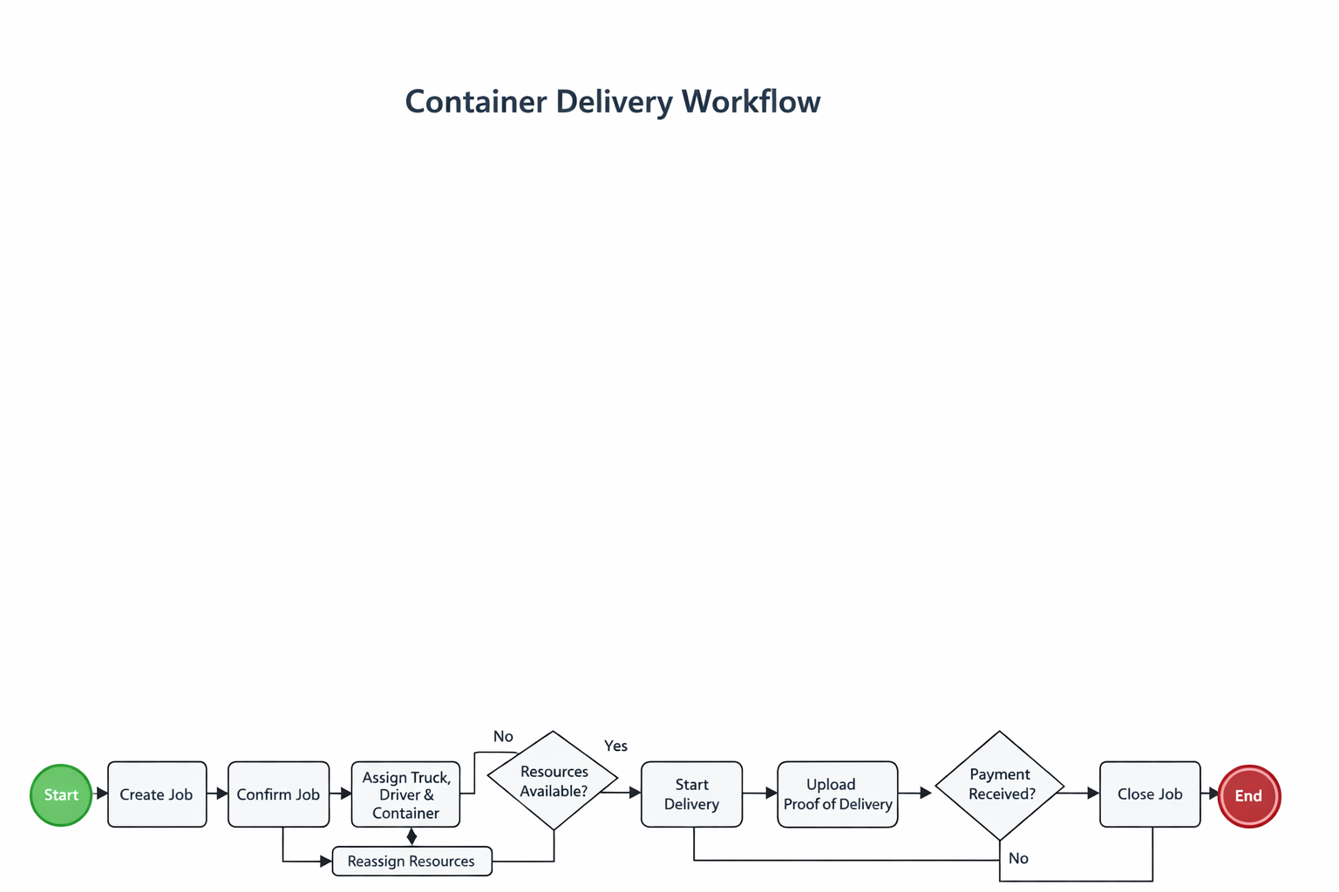

Ethnographic Analysis

Users observed
- Coordinators working under time pressure
- Drivers using mobile phones during deliveries
- Yard staff working physically with containers

Key observations
- Coordinators need fast scheduling tools
- Drivers prefer simple mobile interfaces
- Yard staff need quick updates (not complex forms)
- Mistakes happen when tracking containers manually

Problems
- Double booking of trucks/drivers
- Lost or untracked containers
- Delays in proof of delivery
- Late invoicing

Insights / Improvements
- Add conflict detection (important)
- Mobile-friendly driver interface
- Real-time status updates
- Automatic invoice generation

